**Practical No. 02**

**TITLE:** WIRELESS LAN

**AIM:** TO STUDY WIRELESS LAN

**APPARATUS:** ACCESS POINT

**THEORY:**

**Wireless Local Area Networks:**

**Introduction:**

A wireless LAN (WLAN) is a wireless computer network that links two or more devices using wireless communication to form a local area network (LAN) within a limited area such as a home, school, computer laboratory, campus, or office building. This gives users the ability to move around within the area and remain connected to the network. Through a gateway, a WLAN can also provide a connection to the wider Internet.

Wireless LANs based on the IEEE 802.11 standards are the most widely used computer networks in the world. These are commonly called Wi-Fi, which is a trademark belonging to the Wi-Fi Alliance. They are used for home and small office networks that link together laptop computers, printers, smartphones, Web TVs and gaming devices with a wireless router, which links them to the internet. Hotspots provided by routers at restaurants, coffee shops, hotels, libraries, and airports allow consumers to access the internet with portable wireless devices.

**How is a WLAN created?**

A WLAN can be configured in one of two ways:

1. Infrastructure -

A home or office Wi-Fi network is an example of a WLAN setup in infrastructure mode. The endpoints are all connected and communicate with each other through a base station, which may also provide internet access.

A basic infrastructure WLAN can be set up with just a few parts: a wireless router, which acts as the base station, and endpoints, which can be computers, mobile devices, printers, and other devices. In most cases, the wireless router is also the internet connection.

1. Ad hoc Network -

In this setup, a WLAN connects endpoints such as computer workstations and mobile devices without the use of a base station. Use of Wi-Fi Direct technology is common for an ad hoc wireless network. An ad hoc WLAN is easy to set up and can provide basic peer-to-peer (P2P) communication.

An ad hoc WLAN requires only two or more endpoints with built-in radio transmission, such as computers or mobile devices. After adjusting network settings for ad hoc mode, one user initiates the network and becomes visible to the others.

**Performance Settings of WLAN:**

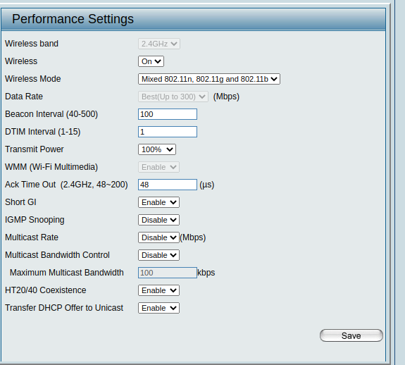

**Wireless Resource Control Settings:**

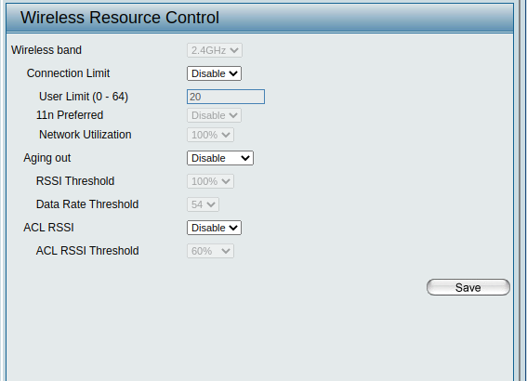

**IEEE 802.11:**

**Physical Layer Architecture -**

The components of an IEEE 802.11 architecture are as follows −

1. Stations (STA) − Stations consist of all devices and equipment that are connected to the wireless LAN. A station can be of two types−

* Wireless Access Point (WAP) − WAPs or simply access points (AP) are generally wireless routers that form the base stations or access.
* Client. Clients are workstations, computers, laptops, printers, smartphones, etc.

Each station has a wireless network interface controller.

1. Basic Service Set (BSS) − A basic service set is a group of stations communicating at the physical layer level. BSS can be of two categories depending upon the mode of operation−

* Infrastructure BSS − Here, the devices communicate with other devices through access points.
* Independent BSS − Here, the devices communicate in a peer-to-peer basis in an ad hoc manner.

1. Extended Service Set (ESS) − It is a set of all connected BSS.
2. Distribution System (DS) − It connects access points in ESS.

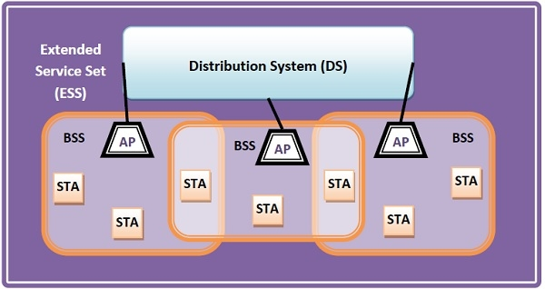

**MAC Sublayer Protocol:**

The 802.11 MAC sublayer provides an abstraction of the physical layer to the logical link control sublayer and upper layers of the OSI network. It is responsible for encapsulating frames and describing frame formats.

The main fields of a frame of wireless LANs as laid down by IEEE 802.11 are −

1. Frame Control − It is a 2-byte starting field composed of 11 subfields. It contains control information of the frame.
2. Duration − It is a 2-byte field that specifies the time period for which the frame and its acknowledgement occupy the channel.
3. Address fields − There are three 6-byte address fields containing addresses of source, immediate destination and final endpoint respectively.
4. Sequence − It is a 2-byte field that stores the frame numbers.
5. Data − This is a variable sized field that carries the data from the upper layers. The maximum size of the data field is 2312 bytes.
6. Check Sequence − It is a 4-byte field containing error detection information.

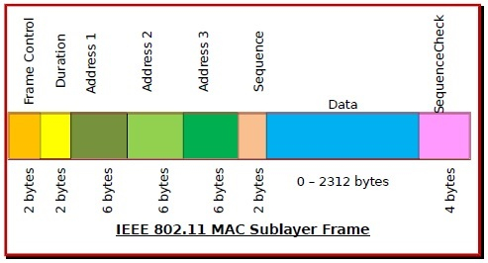

**Avoidance of Collisions by 802.11 MAC Sublayer:**

In wireless systems, the method of collision detection does not work. It uses a protocol called carrier sense multiple access with collision avoidance (CSMA/CA).

The method of CSMA/CA is −

1. When a frame is ready, the transmitting station checks whether the channel is idle or busy.
2. If the channel is busy, the station waits until the channel becomes idle.
3. If the channel is idle, the station waits for an Inter-frame gap (IFG) amount of time and then sends the frame.
4. After sending the frame, it sets a timer.
5. The station then waits for acknowledgement from the receiver. If it receives the acknowledgement before expiry of timer, it marks a successful transmission.
6. Otherwise, it waits for a back-off time period and restarts the algorithm.

**Coordination Functions in 802.11 MAC Sublayer:**

IEEE 802.11 MAC Sublayer uses two coordination functions for collision avoidance before transmission −

1. Distributed Coordination Function (DCF) −

* It is a mandatory function used in CSMA/CA.
* It is used in distributed contention-based channel access.
* It is deployed in both Infrastructure BSS (basic service set) as well as Independent BSS.

1. Point Coordination Function (PCF) −

* It is an optional function used by 802.11 MAC Sublayer.
* It is used in centralized contention-free channel access.
* It is deployed in Infrastructure BSS only.

**MAC Management:**

1. Synchronization

* Finding and staying with a WLAN
* Synchronization function – TSF timer, beacon generation

1. Power management

* Sleeping without missing a message
* Periodic sleep, frame buffering, TIM (traffic indication map)

1. Association/Re-association

* Joining a LAN
* Roaming, i.e. moving from one AP to another
* Scanning, i.e. active search for a network

1. MIB - Management Information Base

* Managing, read, write

**IEEE 802.11a Standard:**

IEEE802.11a is the first wireless standard to employ packet based OFDM, based on a proposal from Richard van Nee from Lucent Technologies in Nieuwegein. OFDM was adopted as a draft 802.11a standard in July 1998 after merging with an NTT proposal. It was ratified in 1999. The 802.11a standard uses the same core protocol as the original standard, operates in 5 GHz band, and uses a 52-subcarrier orthogonal frequency-division multiplexing (OFDM) with a maximum raw data rate of 54 Mbit/s, which yields realistic net achievable throughput in the mid-20 Mbit/s. The data rate is reduced to 48, 36, 24, 18, 12, 9 then 6 Mbit/s if required. 802.11a originally had 12/13 non-overlapping channels, 12 that can be used indoors and 4/5 of the 12 that can be used in outdoor point to point configurations. Recently many countries of the world are allowing operation in the 5.47 to 5.725 GHz Band as a secondary user using a sharing method derived in 802.11h. This will add another 12/13 Channels to the overall 5 GHz band enabling significant overall wireless network capacity enabling the possibility of 24+ channels in some countries. 802.11a is not interoperable with 802.11b as they operate on separate bands, except if using equipment that has a dual band capability. Most enterprise class Access Points have dual band capability.

Using the 5 GHz band gives 802.11a a significant advantage, since the 2.4 GHz band is heavily used to the point of being crowded. Degradation caused by such conflicts can cause frequent dropped connections and degradation of service. However, this high carrier frequency also brings a slight disadvantage: The effective overall range of 802.11a is slightly less than that of 802.11b/g; 802.11a signals cannot penetrate as far as those for 802.11b because they are absorbed more readily by walls and other solid objects in their path and because the path loss in signal strength is proportional to the square of the signal frequency. On the other hand, OFDM has fundamental propagation advantages when in a high multipath environment, such as an indoor office, and the higher frequencies enable the building of smaller antennas with higher RF system gain which counteract the disadvantage of a higher band of operation. The increased number of usable channels (4 to 8 times as many in FCC countries) and the near absence of other interfering systems (microwave ovens, cordless phones, baby monitors) give 802.11a significant aggregate bandwidth and reliability advantages over 802.11b/g.

802.11a boasted an impressive level of performance for its time. It was able to transfer data with raw data rates up to 54 Mbps and at the time it was thought to have a good range, although it could not provide the maximum data rate at its extremes. Even though the raw data rate of 54 Mbps was the headline rate, this was for all the data being transferred over an ideal link and it included all the management overhead data as well. In reality the data rates for the payload data itself were much less, and rates achieved were normally much less than half the headline rate. Nevertheless, the rates were still very good for the day and way above what other wireless communications systems and wireless networks could achieve. It must be remembered that this variant was launched in 1999 when the wireless communications landscape was very different to what it is today.

**IEEE 802.11b Standard:**

802.11b has a maximum raw data rate of 11 Mbit/s and uses the same CSMA/CA media access method defined in the original standard. Due to the CSMA/CA protocol overhead, in practice the maximum 802.11b throughput that an application can achieve is about 5.9 Mbit/s using TCP and 7.1 Mbit/s using UDP.

802.11b products appeared on the market in mid-1999, since 802.11b is a direct extension of the DSSS (Direct-sequence spread spectrum) modulation technique defined in the original standard. The Apple iBook was the first mainstream computer sold with optional 802.11b networking. Technically, the 802.11b standard uses complementary code keying (CCK) as its modulation technique, which uses a specific set of length 8 complementary codes that was originally designed for OFDM but was also suitable for use in 802.11b because of its low autocorrelation properties. The dramatic increase in throughput of 802.11b (compared to the original standard) along with simultaneous substantial price reductions led to the rapid acceptance of 802.11b as the definitive wireless LAN technology as well as to the formation of the Wi-Fi Alliance.

802.11b devices suffer interference from other products operating in the 2.4 GHz band. Devices operating in the 2.4 GHz range include: microwave ovens, Bluetooth devices, baby monitors and cordless telephones. Interference issues and user density problems within the 2.4 GHz band have become a major concern and frustration for users.

**Conclusion:** Thus we studied the IEEE 802.11 Wireless LAN Standard.